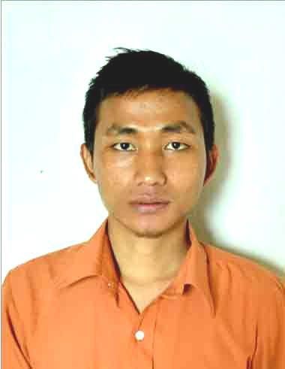
ANDREW LALMUANAWMA

Correspondence Address:
Chaltlang Ruam veng
House No. Block-C M/II/15/2
Aizawl, Mizoram-796012
Contact No:977 477 4802 / 8413843445
Email Id: Andrewlm0006@gmail.com

Permanent Address:
Chhingchhip,Venghlun
Serchhip district-796161
Mizoram

CAREER OBJECTIVE

To be a part of a reputed organization that gives me a platform for career growth and personal development, and to apply the management and Finance concepts I have learned during my studies and from my work experience. To contribute to the success and expansion of an organization and at the same time grow both personally and professionally by continuously increasing my skills.

EDUCATIONAL QUALIFICATION

Year | Board/Univ. | Examination | Institution
2012-14 | UPTU(Uttar Pradesh Technical University) | MBA  (Finance & Marketing) | Institute of Advance Management and Research
2009-12 | ICFAI University, Mizoram | BBA (Management ) | Icfai University, Mizoram-Aizawl Campus
2009 | Mizoram Board of Secondary Education | HSSLC | St. Peter’s Higher Secondary School
2006 | Mizoram Board of School Education | HSLC | St. Peter’s Higher Secondary School

PROJECTS & PAPERS

# “A study on role of advertising in FMCG sector” – February 2014
# “A study on Comparatives analysis of life insurance Companies in India with particular reference to Reliance Life Insurance” at Ghaziabad, Uttar Pradesh
# “A study on Vodafone Postpaid Services in Aizawl” (2010)
# “A study of customer care service of State Bank of India”(2011)

ACHIEVEMENT & ACTIVITIES

- 2014: MBA(Finance & Marketing) – 64.83 (I Div)
- 2012: BBA – 75.20% (I Div)
- 2012: Participated at the National Seminar on “Green Marketing and Society” at IAMR, Ghaziabad.
- 2011:Summer internship training at Vodafone for 2 months(2011)
- 2012 : Score 90.1 percentile in MAT (Management Aptitude test)
- 2009-2012: : Received 50% waiver during studying BBA
- 2008: Worked as Bank Facilitator in Mizoram Rural Bank, Chhingchhip, Mizoram.
- 2013: summer training at reliance life insurance company,Raj nagar, Ghaziabad.
- 2014: Accounting tally certificate from Entrepreneurship Development of India

WORK EXPERIENCE

- Work Regional Rural Bank as Facilitator (2008) for 1year
- Work as Sales Manager at Prestige Private limited (2012)
- Work as Sales Manager at Bajaj Allianz Life Insurance, Aizawl( From 1st sept. 2014- 30th April 2015)
- Marketing officer at ZoCareer Solutions Pvt. Ltd( 20th May 2016 – till date) Career Guidance- Complete Solution to success).

PERSONAL INFORMATION

- Name: Andrew Lalmuanawma
- Father’s Name: Francis K.Thansanga
- Date of Birth: 25th Oct. 1989
- Language Known: English, Mizo
- Nationality : Indian

I do hereby declare that the information given above are true to the best of my knowledge and belief.

Place: Aizawl ANDREW LALMUANAWMA
Date: 16.08.2016

